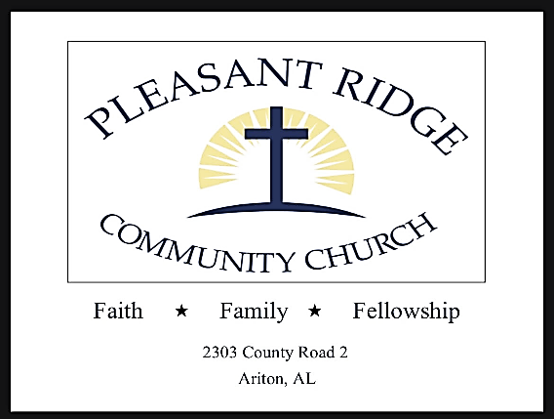

Pleasant Ridge Community Church Seeks Pastor
Are you looking for a new opportunity to share the word of God and become the Pastor of a small rural church? We are looking for a Pastor at Pleasant Ridge Community Church, which is located in Ariton, Alabama. Pleasant Ridge Community Church is a small rural church located between Ozark and Troy, AL. We have recently disaffiliated from The United Methodist Church and currently have an average attendance of around 35. We are looking for a Pastor that wants to share the word of God with the existing congregation as well as lead others to worship here from the surrounding areas.
If God is leading you in this direction and you would be interested in talking with us to get further information, submit your resume to pleasantridgechurch24@gmail.com and someone will get in contact with you. Have a blessed day!

